**Assignment summary**

**Notes: If the code is running from the beginning to the end. The required element would be under the following cells&output.**

**Questions are in purple and answers are in blue.**

**1. Written Report**

✓ How is the district summary affected?

Result without NaN



Result with NaN



After adding NaN to the dataframe, the Average Math Score is reduced, Passing Math, Passing Reading and Overall Passing percentage is also reduced.

✓ How is the school summary affected?

No effect on other schools. Only for Thomas High, the Average Math Score is reduced, average reading score is increased. Passing math and Passing reading ration is reduced. And overall passing ratio is reduced. Thomas is now out of top 5 schools.

Without NaN





With NaN

✓ How does removing the ninth graders’ math and reading scores affect Thomas High School’s performance, relative to the other schools?

No effect on other schools. Only for Thomas High, the Average Math Score is reduced, average reading score is increased. Passing math and Passing reading ration is reduced. And overall passing ratio is reduced.

✓ How does removing the ninth grade scores affect the following

- Math and Reading Scores by Grade No effect on other grade. Only effect would be on 9th grade. 9th grade reading and math score for Thomas will become nan.

- Scores by School Spending No effect on other spending range except spending range $630-644. For the spending range $630-644, average math score is reduced, average reading score is increased. Passing math, passing reading and overall passing ratio are all reduced.

- Scores by School Size No effect on Small and Large Size. Only for Medium size, passing ratio for Math, Reading and overall are reduced.

- Scores by School Type No effect on District School. Only for Charter School, passing ratio for Math, Reading and overall are reduced.

**2. Expected output displayed**

✓ District Summary

Related cells: Out[32]



✓ School Summary

Related cells: Out[45]

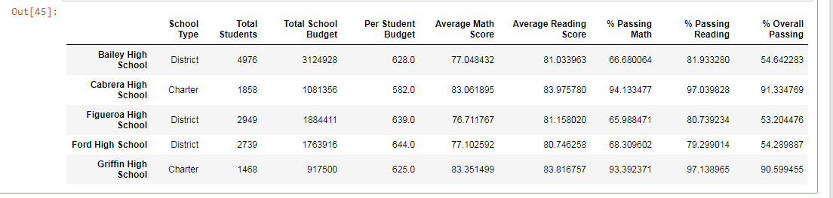

✓ High and Low Performing Schools

Related cells: Out[47]

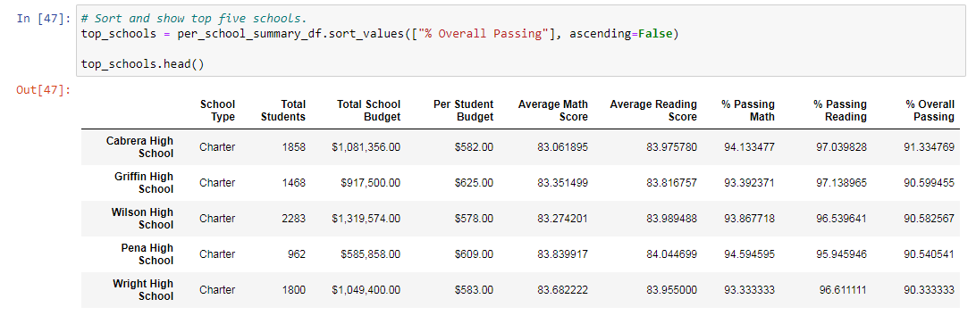

Related cells: Out[48]

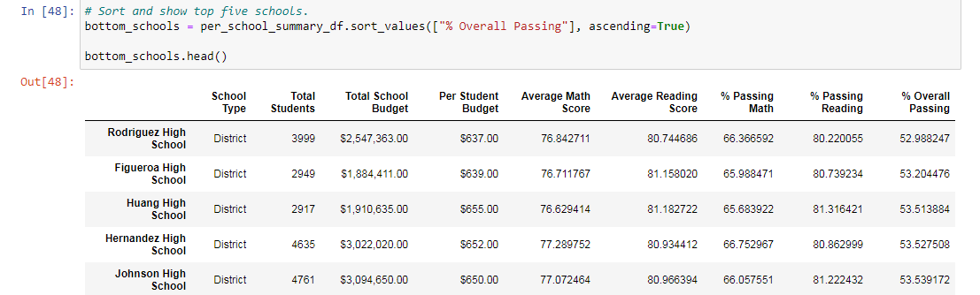

✓ Math and Reading Scores by Grade

Math score Related cells: Out[54]

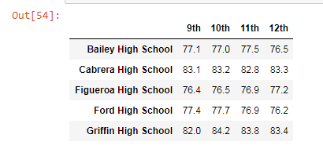

Reading score Related cells: Out[55]

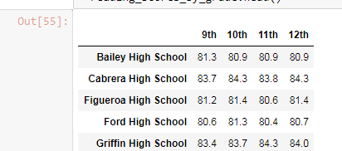

✓ Scores by School Spending

Reading score Related cells: Out[63]

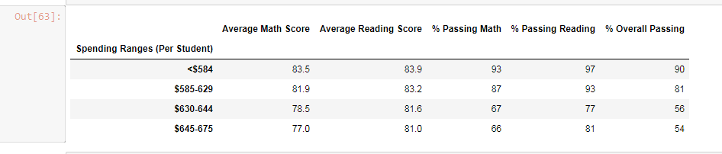

✓ Scores by School Size

Reading score Related cells: Out[68]

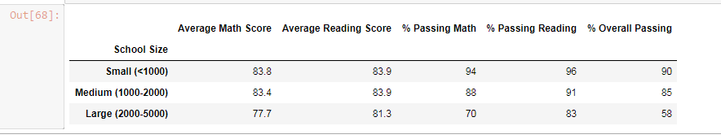

✓ Scores by School Type

Reading score Related cells: Out[71]

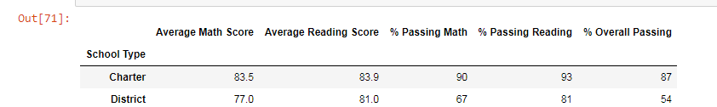

**3. Functions used on DataFrames**

✓ Mean

Related cells: In [20]



✓ Sum

Related cells: In [19]

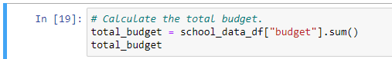

✓ Count

Related cells: In [17]



✓ Cut

Related cells: In [57]

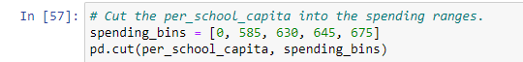

✓ Map

Related cells: In [31]



✓ Format

Related cells: In [31]



✓ Sort values

Related cells: In [47]



✓ Merge

Related cells: In [15]



**4. GroupBy used**

✓ Math and Reading Scores by Grade

Related cells: In [15]

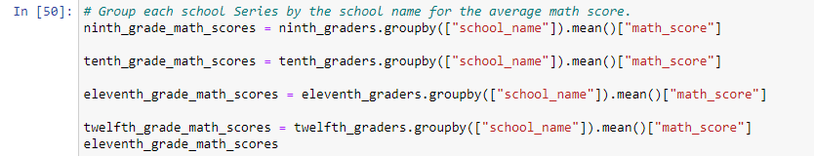

Related cells: In [51]

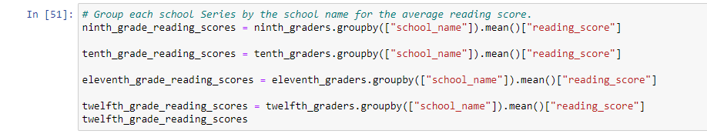

✓ Scores by School Spending

Related cells: In [61]

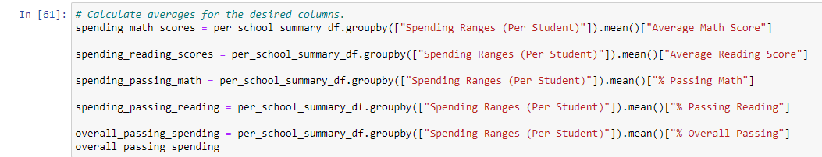

✓ Scores by School Size

Related cells: In [66]

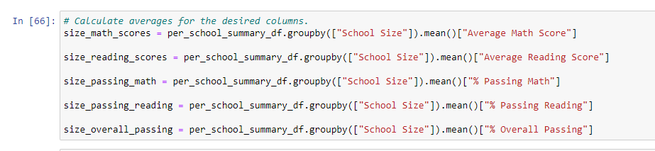

✓ Scores by School Type

Related cells: In [69]

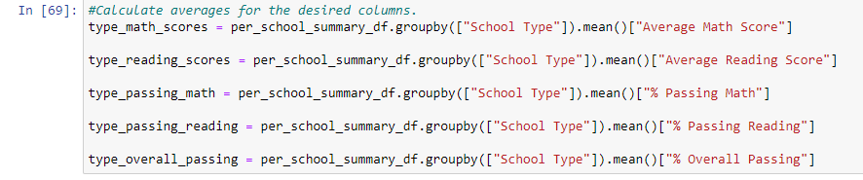

**5. Drop rows or use NaN to replace values**

✓ Replaces **both** the **reading** and **math** scores for the 9th graders in Thomas High school with NaN.

Related cells: In [12]-In [14]

